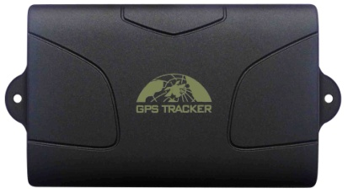

Model: TK104
GPS Portable Asset Tracker
This tracker is a new product based on the GSM / GPRS network and GPS satellite positioning system, which set multiple functions of security, positioning, monitoring surveillance, emergency alarms and tracking in its entirety. It can track and monitor remote target by SMS or internet.

Detailed description:
It is based on GSM/GPRS（850/900/1800/1900MHZ）wireless telecommunication internet and GPS satillite global position system,track by several ways.provide monitor software and global map.real-time track through the monitor software in your pc;track through your PDA cell phone and googleearth.
Features & Functions
-Waterproof shell
- Built-in large capacity 6000MA battery, long standby time of 60 days.
- Powerful magnets to absorb to vehicle firmly.
-Real-time tracking, retrieve of lost vehicles, cargo.
- Movement alarm, Geo-fence alarm, shock sensor alarm, remote monitoring.
-Support map viewing on mobile phone screen, get absolute address by SMS, GPRS real time tracking on web based server.
- Built-in high sensitivity GPS and GSM antenna to make it can be used alone without installation, convenient and quick.
-Support for external GSM antenna, GPS antenna, and external power supply for the tracker to be installed on the device which can provide power for long-term using.
-tracking function by timing and frequency
-Geo-fence: Set up a geo-fence for the unit to restrict its movements within a district. The unit will send the message to the authorized numbers when it breaches the district.
-Movement alert: you can set up barriers when the vehicle is stopped. Once moved, it can give an alarm to the authorized number.
-Over speed alarm: you can make the inspected target run according to fixed speed. It alarms when speed is exceeded.
-Low batttery alarm function
-Remote Engine-stop and Resume.

Applying directions:
Locating and tracking service for cars, trucks, container trucks, special vehicles, cargo and criminal investigation officer.
Technology parameter:
-GPS chip: SIRF3chip
-GPS sensitivity: -159dBm
-GPS accuracy :5m
-Time To First Fix Cold status 45s,Hot status 1s
And there is 4 tracking solutions:
-SMS tracking on cellphone with a googlemap link to view current location on map on cellphone screen.
-Get absolute address by SMS
-PC Installation software tracking.
-Web server online tracking www.gpstracker.in www.gpstracking.co.in

Bonrix Software Systems
A-801, Samudra Complex, Near Classik Gold Hotel, Off C.G.Road, Ahmedaba, Gujarat, India..
Phone : +91-9426045500, +91-79-26426364
E-Mail : info@bonrix.net
Website: www.bonrix.net, www.bonrix.co.in

